Lake Wohlford, Couser and Rice Canyon Loop
14 September 2013
By Rob Verfurth

The day started in heavy fog as Bob P and I drove over to the mall to start the ride. By the time we arrived, the sun was pushing through and the temperatures were rising. The Descenders group ride in the north county area included some of my favorite climbs—Wohlford, Courser and Rice. We had a large turnout of 18 riders; actually 19 if you count Matt B who quickly abandoned us for the Ranchos ride. We had many of the usual suspects and a few guests: Brian from Scotland, Manuel and Jason. The rest of the riding gang included birthday boy, Jeff Southerton, Guido, Garet, Eric R, Rick, Eileen, Hodges, Claus, Bob P, Steve K, Ernst, Larry, Tony, Voris and me. Jeff celebrated his 50th birthday on Saturday.

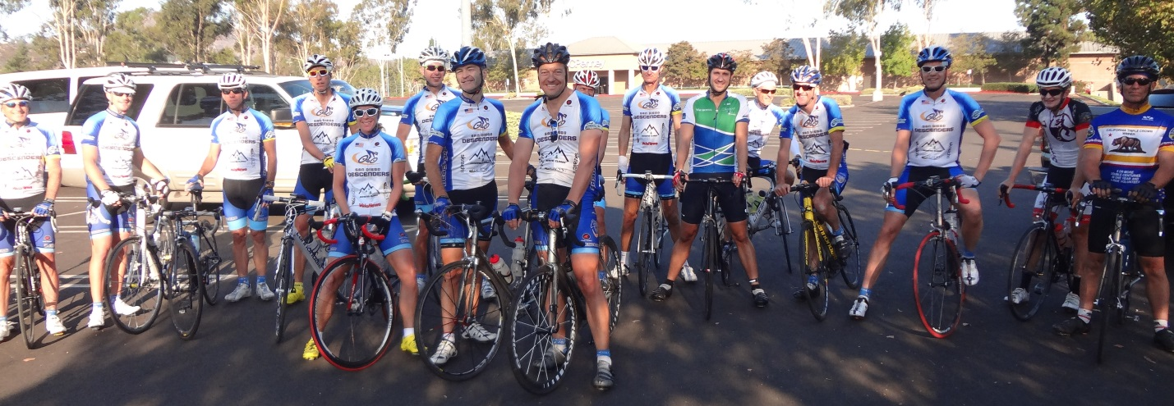
Group Start at mall

Unfortunately there was no Oleg for this ride. Without “Megapixel” Oleg, the reporting and photography were left in my incapable hands. This causes a number of issues during the ride. Most of the moving photos are of riders backsides since I am rarely near the front. Any photos taken from the front usually require me to burn a few matches, of which I have little to spare. Most all the photos are taken in the early part of the ride because I am usually so far to the rear by mid-ride that I have no one around to be the subject of a photo. Many photos are deleted from those downloaded due to poor quality of image (blurred picture). All that said there were a few decent enough photos taken on the ride and I do remember some of the events to include in the ride report.

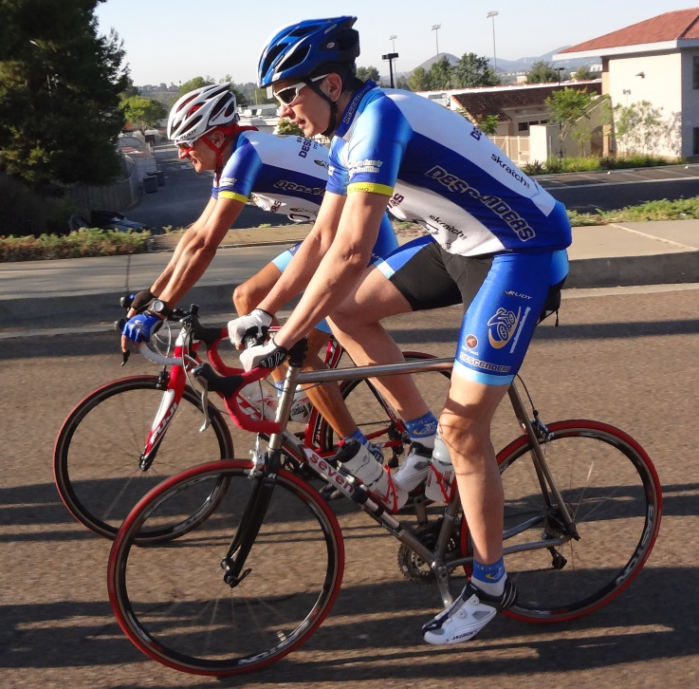  Bob P and Voris on Mary Lane | 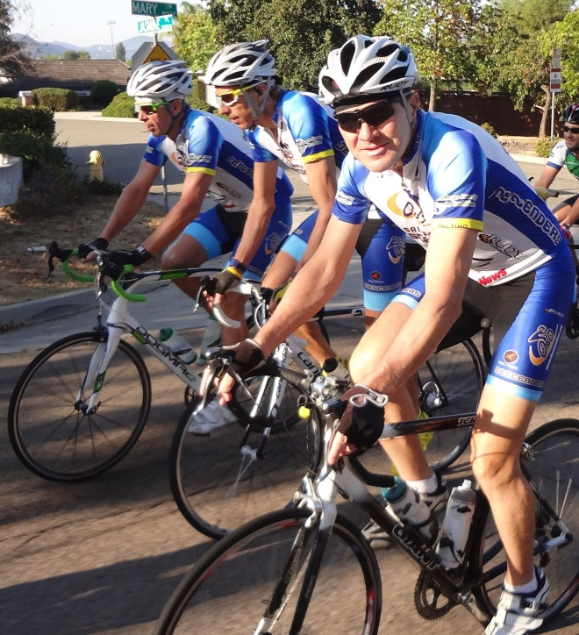  Jeff, Rick and Steve K cruisin’

The group stayed together on our usual route to the bottom of Lake Wohlford. At the start of the climb the guys took off and I quickly settled in the rear and swept up all stragglers, just me. Regroup was at the top where everyone was catching their breath and counting heads. We already lost Garet who seems to always have to get back home to the family, good man.

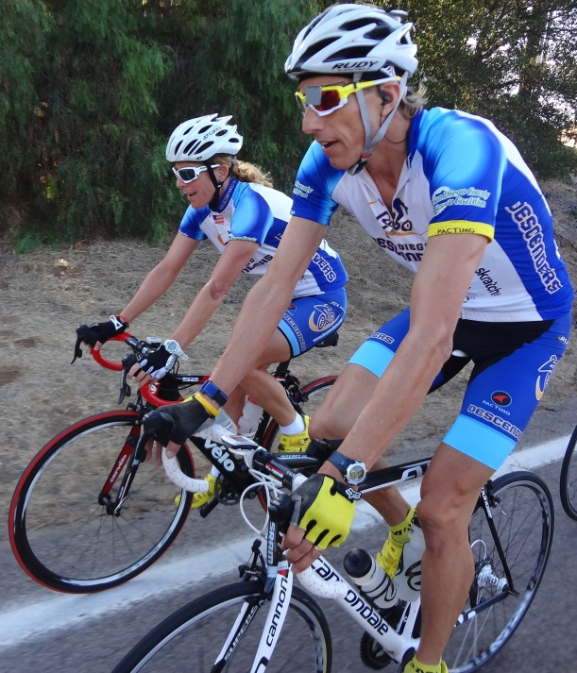  Eileen and Rick on Summit Drive | 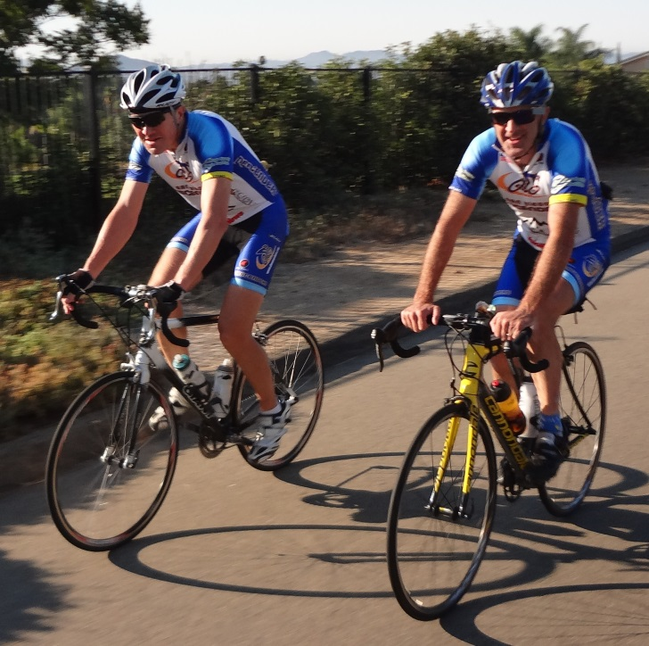  Tony and Steve heading to Wohlford
Claus and I snuck out a bit early from the break to get a small lead we knew would be swallowed up soon. Ernst came to pull on point while Guido hung on behind me. The rest of the gang came fast and flew by ahead of the slight hill before we turn onto Woods Valley. Claus and I took point to get things rolling again after a slow start on Woods Valley. I hid behind the German kugelporsche for a few turns before Larry and Eric came to the front. For the next three miles Eric and Larry took turns rotating at 32 mph while the rest of us just hid behind the guys in front and hung onto the fast pace. After the golf course I took a short crack at pushing to the front to get the final surge going. My time was so short it only lasted long enough to help Guido get by me. He pulled for the traffic light. Eric reacted but could not catch Guido before the turn at Valley Center Road. It was a fun, fast section of ride; great pulls by Larry and Eric.

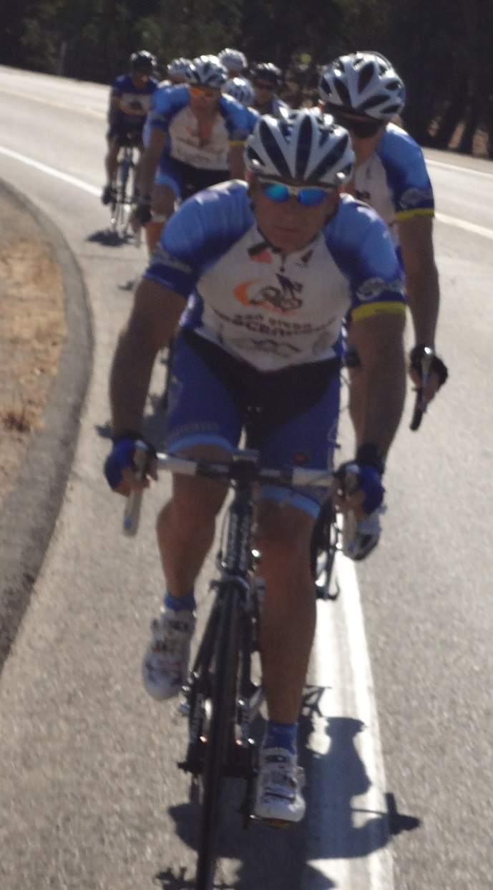  Guido still on point on Lilac | 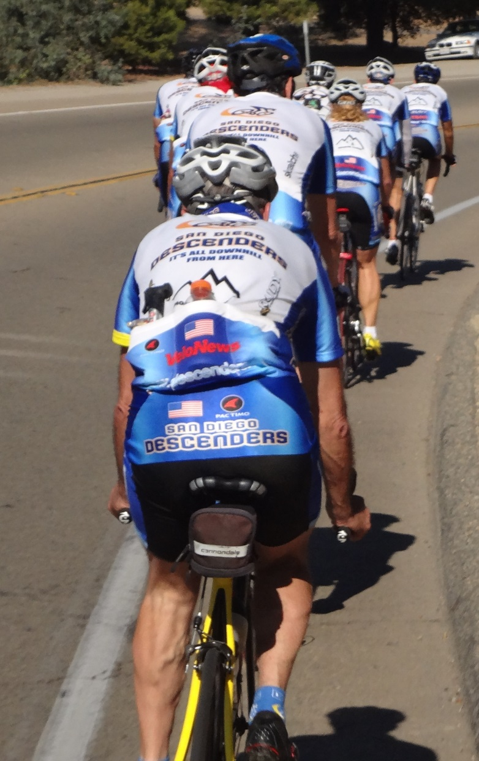  Tony sweeping group on Lilac
We all rolled together along Lilac, past the Daisy Deli and to the start of the Couser Canyon climb. The front pace was fast as I could see from my ever increasing distance in the back. Everyone topped the crest ahead of me so I pushed on looking forward to the fun, curvy descent ahead. It was a great sight to see that the Descenders flying around the curves up in front. I managed to close the gap some through the first descent and kept up a good pace until the last mile in the flats. I saw four riders in a line and I could not get any closer as we all regrouped at highway 76. I set a PR on the top portion of the descent.

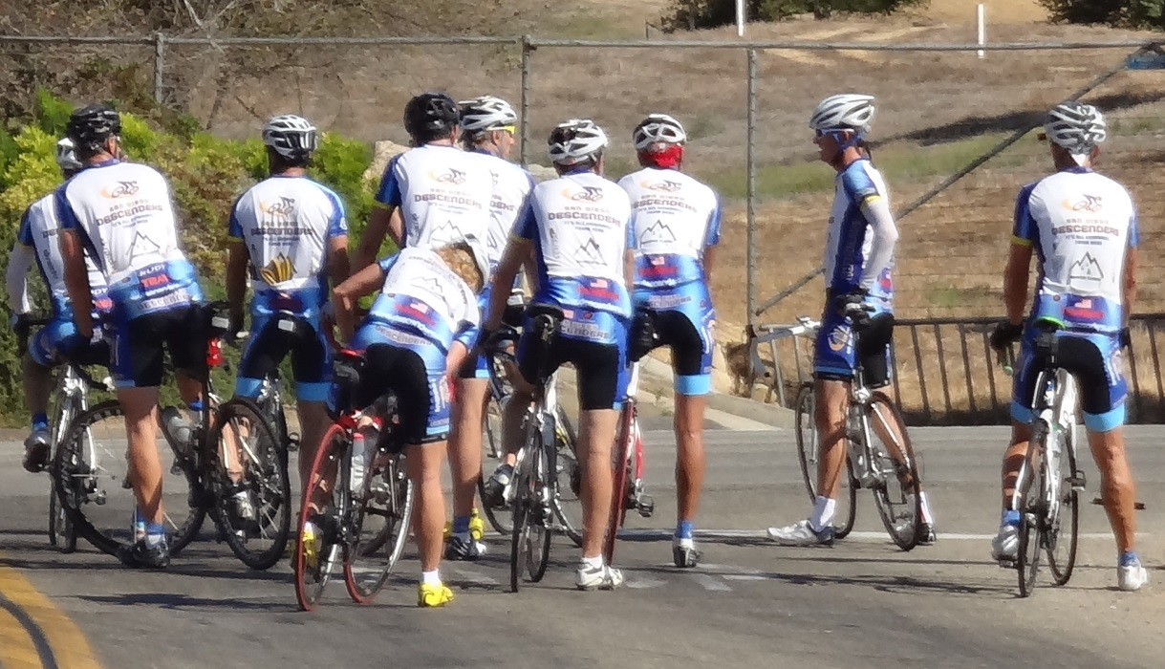
Regroup at Highway 76

Voris wanted us to vote on the Rice Canyon (optional) at the start. There was no consensus then but now was the time to make a decisoin. Some of the group headed left onto Hwy 76 to go through the neighborhood and climb back up 395 to the Lilac Bridge. The rest of the group turned north onto Rice Canyon.

There were seven of us that added the Rice Canyon climb to the ride. Hodges, Claus, Guido, Bob P, Brian, Tony and me. At the start of the climb Brian got stung by a bee in the face and he started to have a bad reaction. His face swelled dramatically, almost closing his eyes. Fortunately we had some benedryl that helped reduced the swelling. The group climbed and I fell off, riding alone to the top. It was a pleasant day and I had little left to push the pace so a smooth pootle climb for me. Guido and Bob were waiting for me at the top. Hodges led the other guys to the Rainbow Oaks Country Market, a mile north of our usual church stop. The market was great and had outdoor shaded tables so we could rest up a bit. Lots of water and sodas help replenish the spirits.

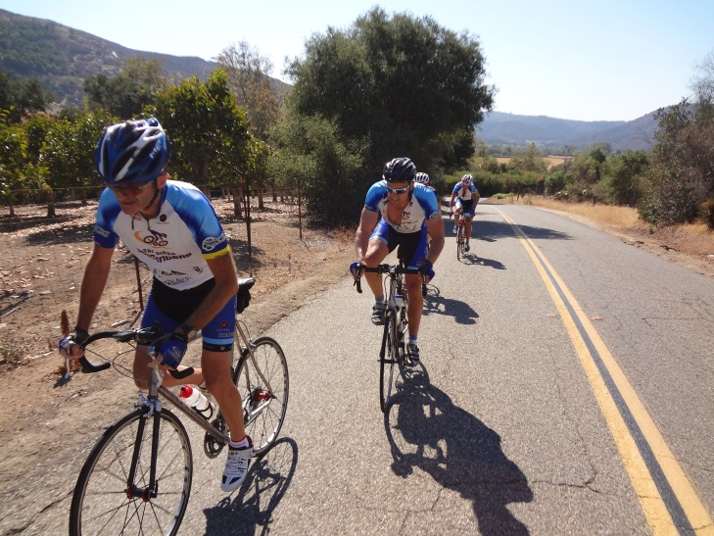  Mike and Claus led climb up Rice | 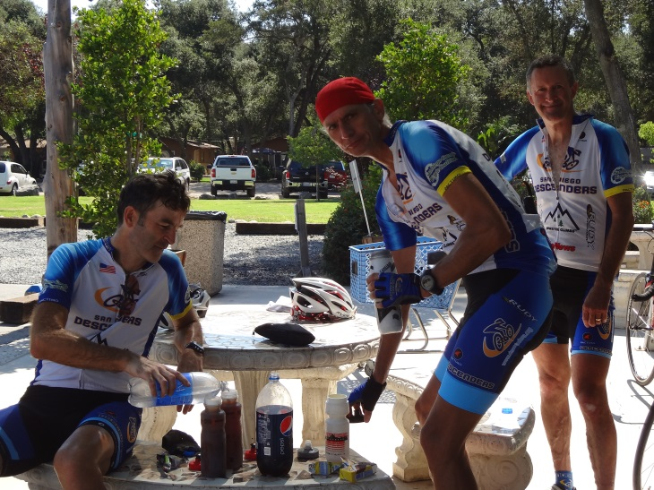  Mike, Bob and Tony relaxing in Rainbow

We all headed south on 395, past Pala Mesa Resort, to the climb up to the Lilac Bridge. Hodges said he planned to roll slow and told the rest of the guys not to wait for him or me.

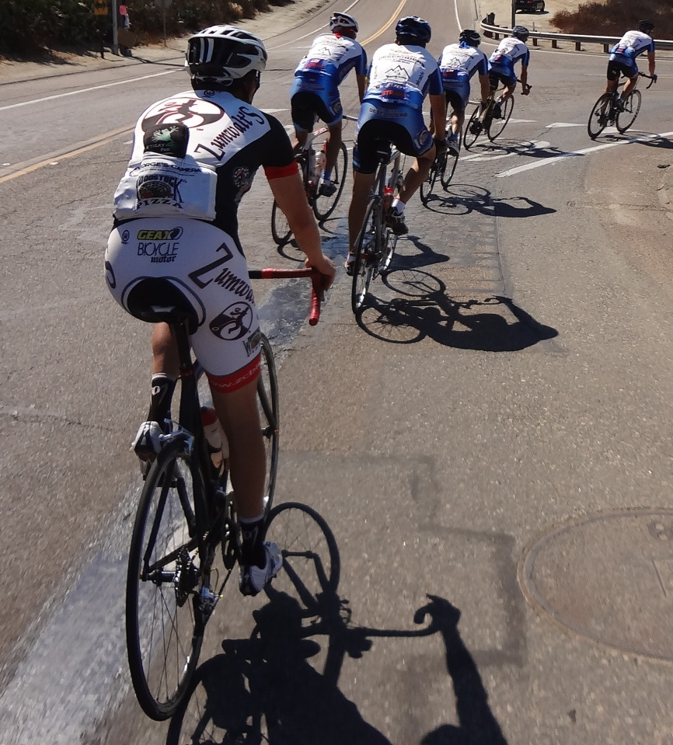
On the climb Mike slowed back to me and then slowed some more. I rode solo the rest of the way back to the mall. The other five guys were out front and Mike was behind. I slowly made my way past the Welk Resort and planned to skip Jesmond Dene to cut into the lead of the guys in front. My ride home was in the group as well.

I did not set any segment marks as I made my way down through City Centre of Escondido and into the neighborhoods behind the mall. I finished at 64 miles and just under 5,000 of climbing. Guido and Bob P rolled into the parking lot a few minutes later. Good timing and a great ride.

