BWR Training Ride Reports
22-23 February 2014
By Rob Verfurth

Saturday Ride-RSF, Del Dios, HVR, Mussey and SPP Loop

The group ride started at the corner of Black Mountain Road and the 56 bike path. We had a good large group with lots of fast riders. We had a few riders who have not ridden often join the ride, including John and Joel. Myron was a new rider to the group. John last rode with us in June when he provided me needed medical attention after my fall on Old Julian; good to have it back out riding, just in case. John is super strong and rode at or near the front for much of the early part of the ride where I was still in attendance. We had a total of about 18 riders.

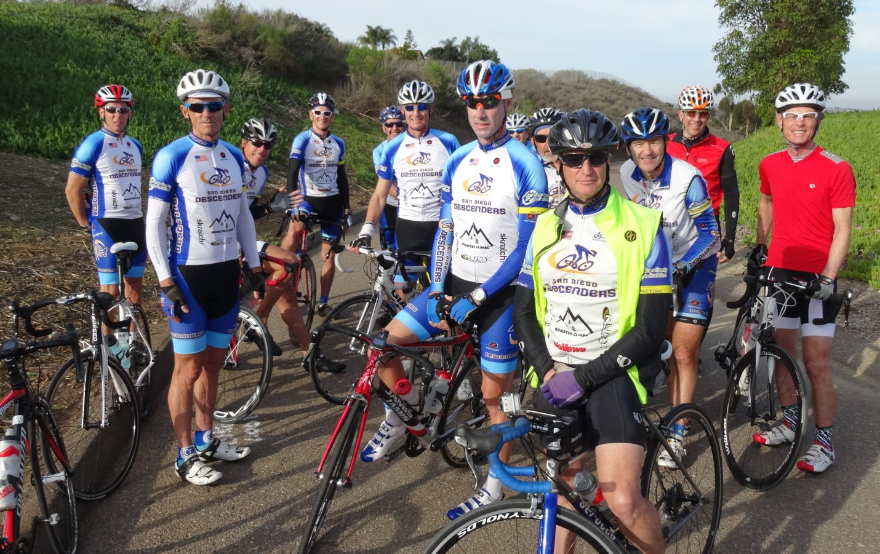

We cruised down the bike path to CDS and picked up Dave Sheehan who was just getting dropped off. Dave S was just returning from another of his worldwide business travels and feeling the effects of a lingering chest cold. He rode at the front for as long as he could, hogwash! We picked up Bob Proulx as we rode by Santaluz and flew down Three Witches. Jeff Southerton met up with us and now we had our full group of riders.

The pace coming into RSF was quick and then we hit Stud Loop hard. A group of about 12 riders or so rode together before we split when Matt, Larry, John, Guido, Ernst and Jeff S pulled away from us. I hung on Tony’s wheel until Rick W roared by us. I closed the gap to his wheel and hung on to the end of Stud Loop, with Bernie, Tony and Bob P just behind us. A new PR for me thanks to Rick W and all the other guys I hid behind. We waited at the corner of S6 for everyone else to regroup.
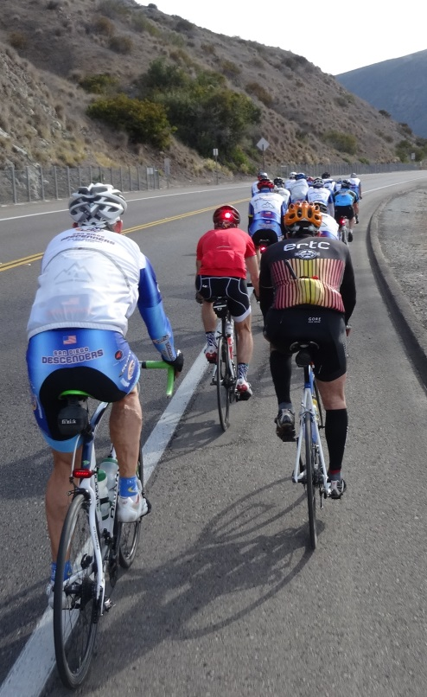  Climbing Del Dios Highway | 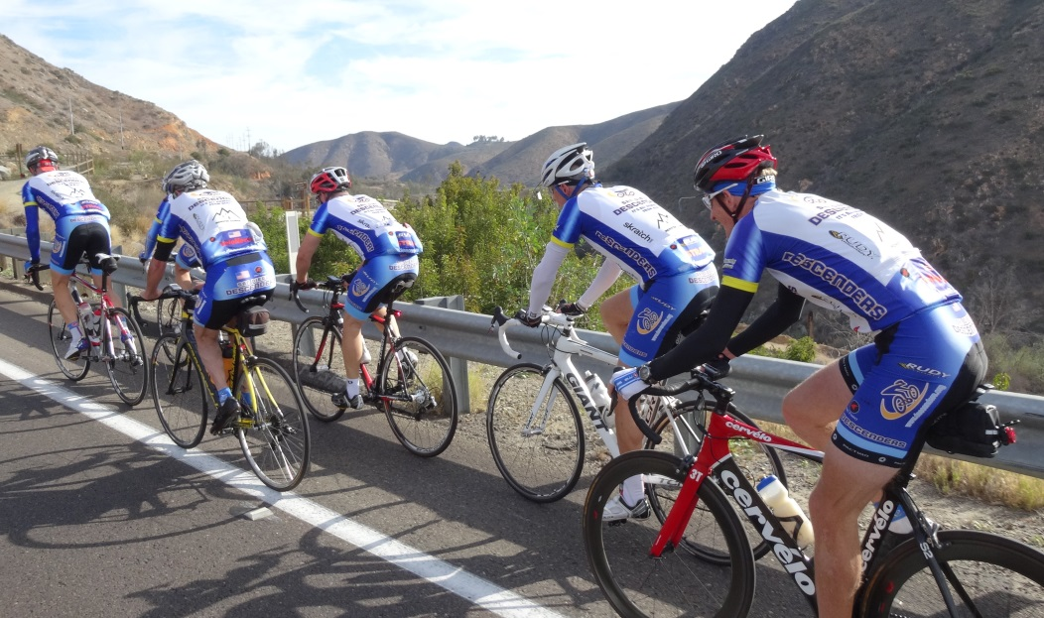  Del Dios by Lake Hodges Dam-Matt, Guido, Tony, John, Ernst and Bernie climbing past the dam

Sheehan skipped Stud Loop and was now out in front on Del Dios, we all rolled after him. The pace was again quick and the group split on the climb past the dam. Jeff S turned to ride back to the coast. We rode to Lake Drive and cruised along the nice road, underneath the large oak trees.

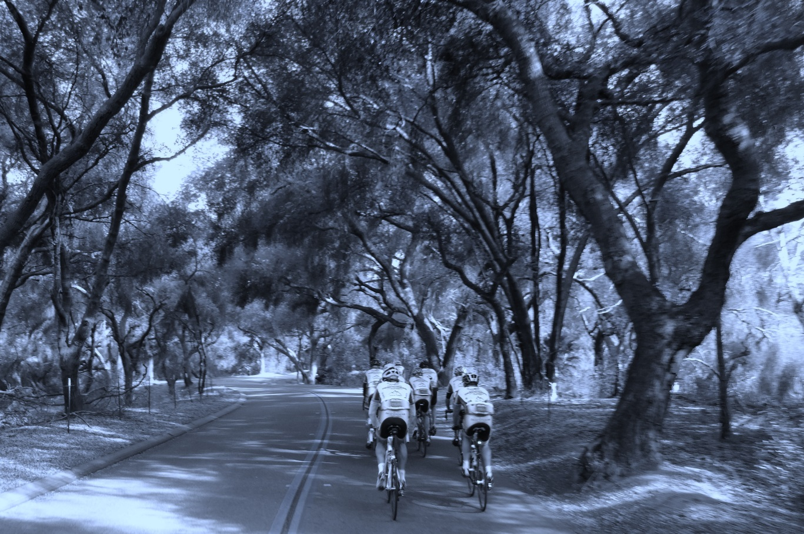
At the corner of Via Rancho Parkway, Myron had to change a flat. Some guys stayed to fix the tire while the rest of us rode to the gas station where a planned regroup took place. This is where my ride went into the parallel universe of BWR training. The plan was to ride over the Lake Hodges pedestrian bridge and up HVR to Ramona. Mike Hodges wanted to get in as much dirt riding as possible so he convinced me to ride across Mule Hill to HVR. I was game, what harm could come from it?

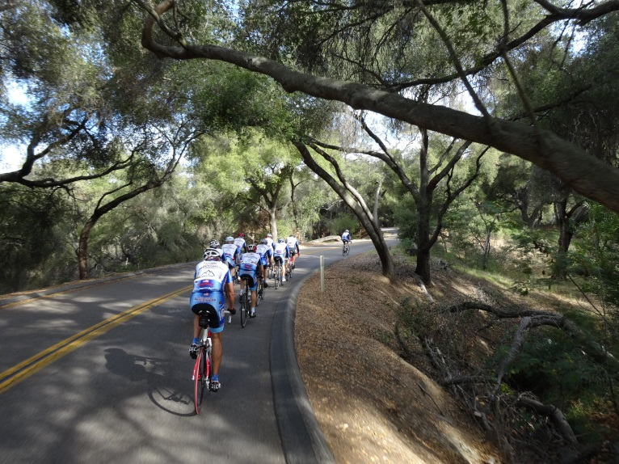  Lake Drive Climb | 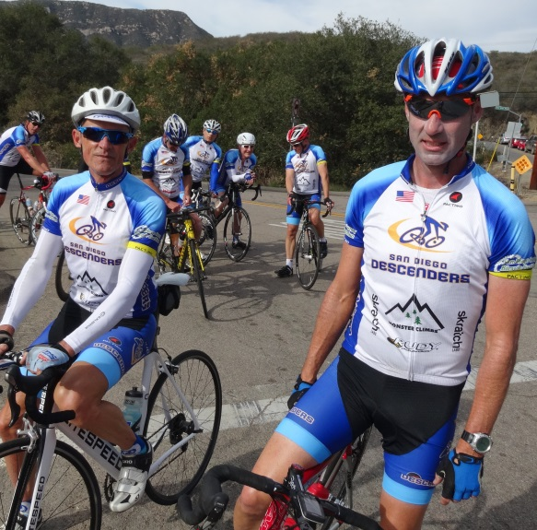  Larry & Matt at Via Rancho Parkway

I like riding the dirt and had ridden Mule Hill trail previously—the BWR event and other rides with Mike. We had always ridden east to west; this was our first ride heading east to HVR. The trail is wide and mostly smooth with only a few rocky and soft, sandy sections. We made good time until my rear tire got noticeably softer. I rode to the end on a flat tire and we did a tube change where the trail hits HVR. The rest of the Descenders group flew by us yelling or laughing or just saying hi; could not tell but they were gone in a flash. Sheehan stopped to chat with us as he was planning to head home from HVR anyway.

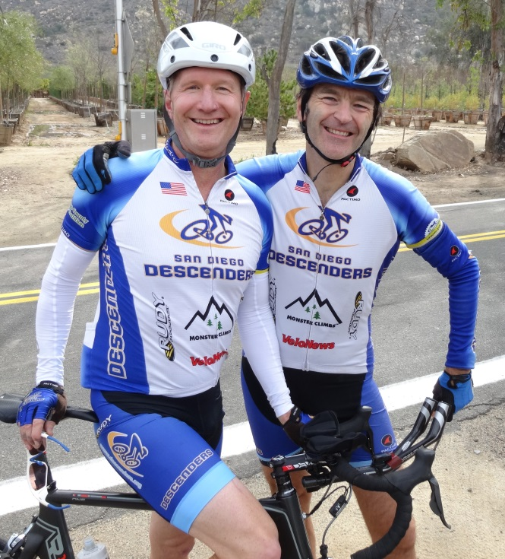  Sheehan & Hodges on HVR | 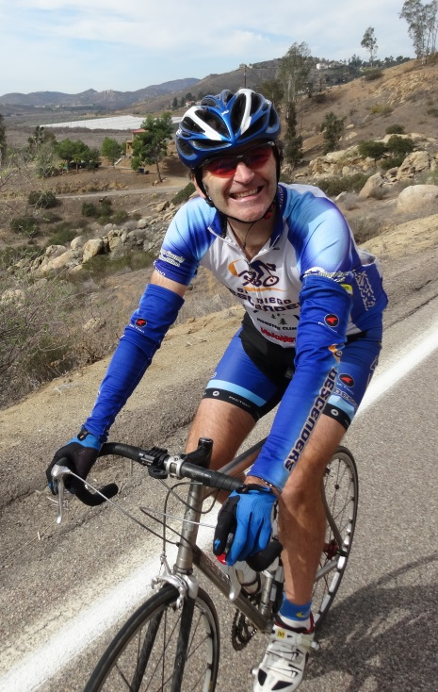  Hodges climbing HVR
After fixing the tire Mike and I started up HVR. I rode ahead of Mike and then realized I would likely be alone the rest of the ride so I dropped back to ride up with Mike. He was taking a fairly easy pace but I did not know what riding plans he had for the day. I had to return home early to go downtown so I was cutting over on Archie Moore Road when I got to the top of HVR. Bob P was going to head back as well but he was out way ahead of us in the lead group. We rode up slowly and got to the top of HVR where I turned at the school; no sign of Bob. Mike continued on to ride to Mussey Grade and much, much more. I will cover those details later. I cruised up Archie Moore and heard a whistle behind me. Bob P and the rest of the guys had stopped at the corner past the school and he was waiting for me when Mike rode by. He easily caught up to me on the climb toward Mt Woodson golf course. Bob and I rolled (he pulled me) along 67 and down Poway Grade to Twin Trails and back to the 56 bike path. A little over 52 miles for me and I was done for the day, others were not. I cleaned my bike and made sure my tires were ready for another ride; turns out I should have left it dirty.

I know the rest of the group did Mussey and returned back via SPP but have little info on the rest of the ride. I am sure it was fast and furious with Matt, Larry Rick W, John, Bernie, Tony and Guido in the group. I headed downtown about 12:30 or so and saw Guido on his way back into PQ. I reviewed the ride of Hodges for the day. He saw the group climbing up Mussey as he descended. Mike went beyond the gates and down all the way to the San Vicente Reservoir doing more exploring. He then did a hike a bike up Dos Picos and over to get back to the 67. Mike and I rode there last summer but bailed way before the rocky stuff he hit on Saturday. Mike also rode up to the top of Mount Woodson, guess he was looking for Potato Chip Rock. The road is said to be super steep but fairly clean. He then cruised back into Ramona and down the 78 back towards Lake Hodges and rode Del Dios the other direction with a final climb up Three Witches for fun. Mike pounded out almost 120 miles for 8.5 hours of riding in his Saturday ride. Bob P saw him slowly heading towards his home after 4:30 pm, an all-day BWR training session to say the least.

Sunday Recovery Ride—Lake Hodges, Mt Israel, Mule Hill, HVR, Bandy, Summit, Mary Lane, 4S Loop

I rode alone over to Spring Meadow early on Sunday for the planned recovery ride. Hodges volunteered to host so I knew that meant more BWR trails. I suggested a loop that included mule hill again and cruise around the roads north of the mall as Mike had to get there for an 11 am family event; Mike had other ideas. We rode together to the start at Pomerado and RB. There were a few guys there from the Saturday ride—Tony, Len and John M. Claus was also riding today and a new rider, Herman. He is from Austria and a local chef; our international contingent and flavor continues to expand. Herman had a nice bike with carbon wheels and looked like he was ready to hammer. Sheehan was supposed to ride but by about 8:07 we rolled towards Lake Hodges. Dave S did ride, he was behind us trying to get to the 8 am start by 8:10, and we never saw him as he rode up HVR. Mike had us do a much different route.

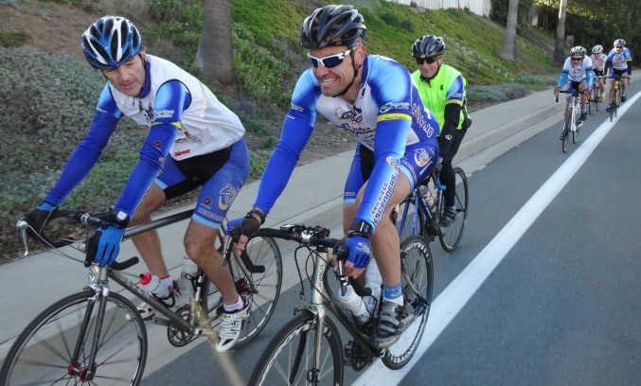 Mike and Claus on point riding along Pomerado Road
Mike explained his ride plans: head over the pedestrian bridge and go left to the marina and out onto Lake Drive. Ride back to the mall and take Mule Hill to HVR. Sounded fine to me but we had a new rider, Herman, and guys who are not huge fans of dirt. I cautioned this approach and made sure everyone knew what Mike had just said, all were up for the adventure. We set off for Lake Hodges.

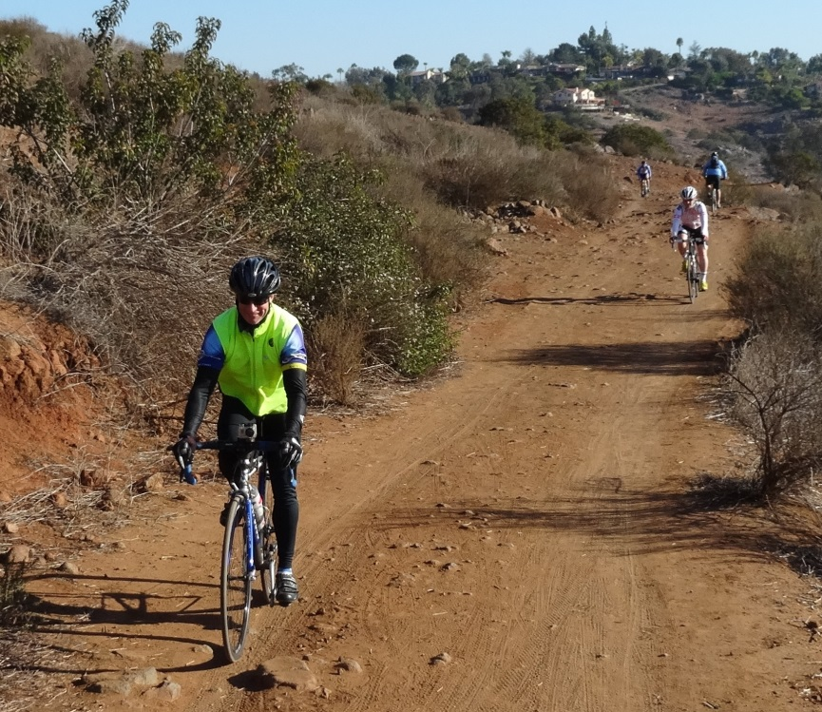  John, Herman and Claus on trail | 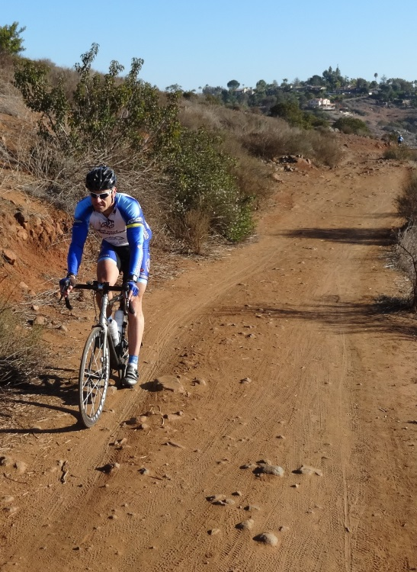  Claus loves BWR Training

Claus was giddy to learn that the BWR trails on the north side of the lake were so close to his house and fairly smooth for a road bike. We hit the pedestrian bridge and turned left with Mike on point and me chasing. As we crossed the creek I asked Mike to slow and wait to make sure all the guys made it. I rode up the rocky hill and along the trail until we hit a flat section where I could stop to wait and take a few photos. Claus was smiling and saying he was going to train on this section before the BWR event as he rode by me. We all made it to the marina, some a little more wobbly than others.

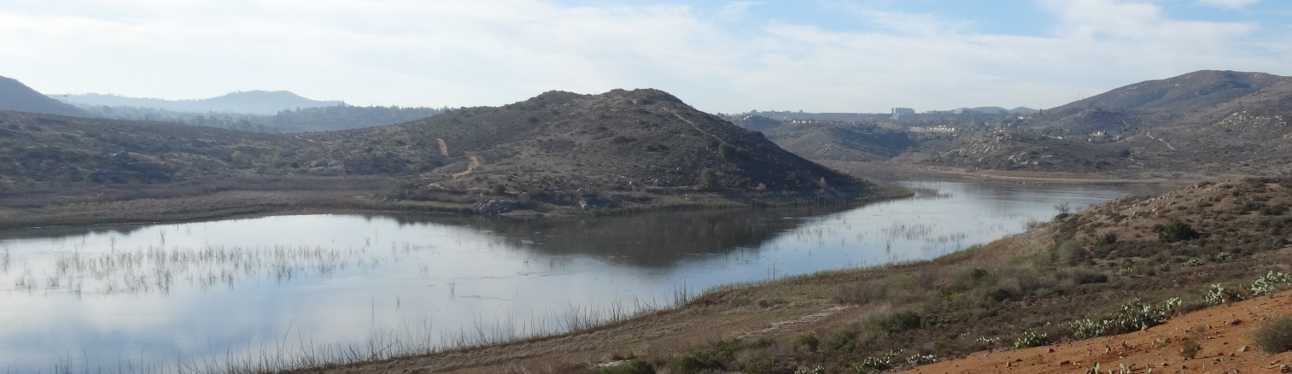
Lake Hodges view to the south
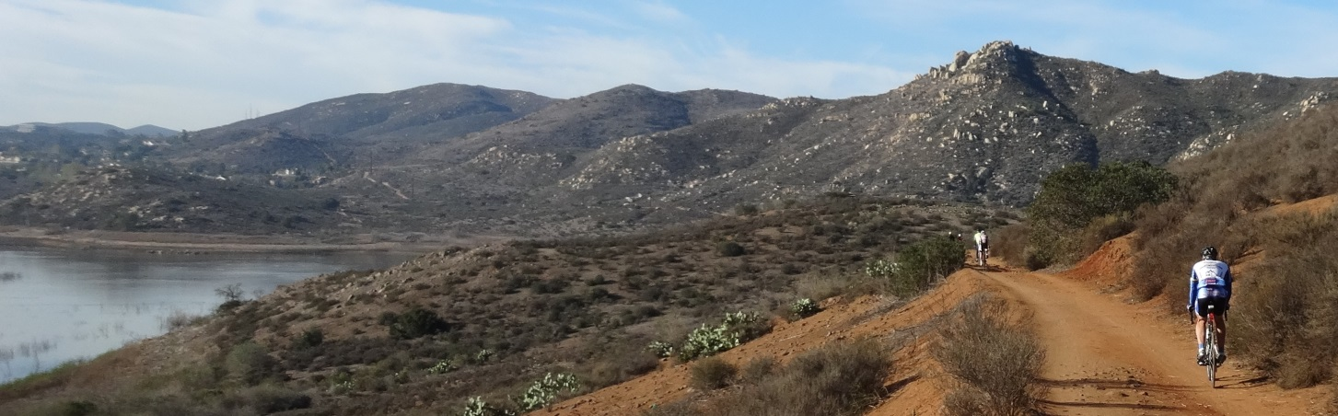
Claus on Lake Hodges Trails

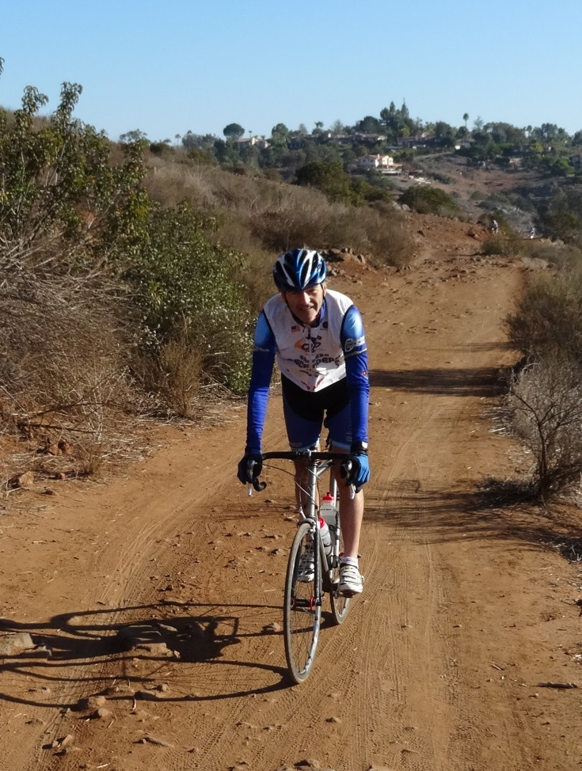  Our Fearless Leader | 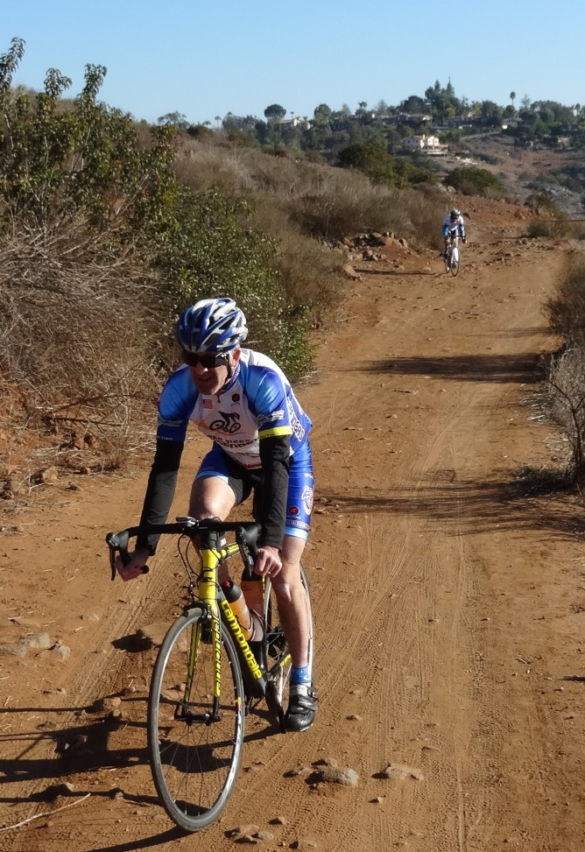  Tony & Len-Get the heck out of here!

Mike stopped to speak to a couple walking on the trails. He pointed northwest towards the Del Dios Highlands Preserve asking how we could get up that road. The couple lived up by the Olivenhain Reservoir and the man had ridden up the road once on his mountain bike. He said it was not possible to ride up on our bikes. I agreed as I had looked at that rocky, sandy, dirt road years ago; it was beyond BWR training. Fortunately Mike was persuaded to not attempt this futile effort. Unfortunately the man mentioned Mount Israel.

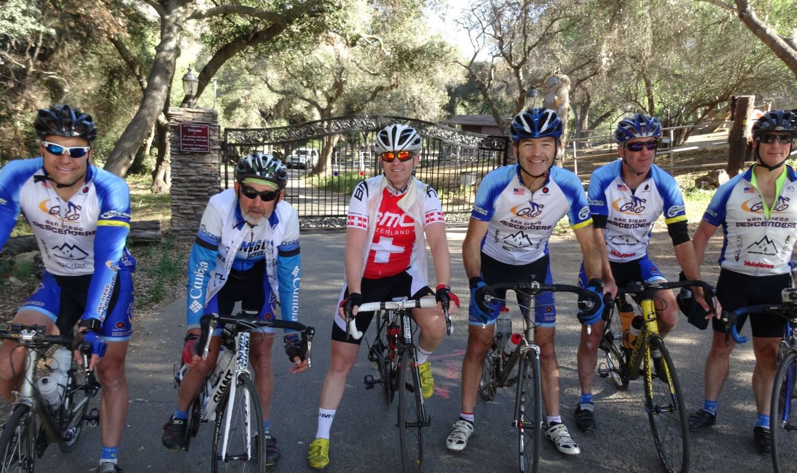
Boys on top of Mt Israel

We rode to Lake Drive and turned left, climbing past Hernandez Hideaway to get back to Del Dios. We made the quick right turn and then left to Mt Israel Road. This is only about a 1.3 mile section, but steep, that stops in a pretty oak tree grove at the end of the road. Claus and Tony led the way up and I caught them at the top before we took the slight descent to the end of the road. It was gratuitous climbing for sure and not exactly a recovery ride. The return is the scary part for me with the super-fast curvy descent back to Del Dios. We regrouped and returned to Lake Drive for the cruise to Via Rancho Parkway and over towards the mall. After a water and bathroom break at the gas station it was onto Mule Hill Trail.

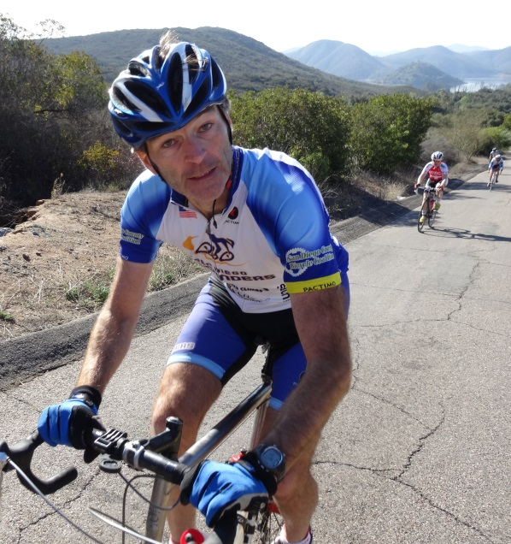 Mike climbing up Lake Drive

Just like the Saturday ride we split the group. Len, Tony, John M and Herman had seen enough BWR dirt trails for the day. They rode over the bridge to HVR. Mike, Claus and I rode Mule Hill Trail and got to HVR well ahead of the other guys, no flat tire. We planned to regroup at the Bandy Canyon turn. I took off and saw the other guys coming as I rounded the second turn. Tony was on point and closing fast. He passed Mike and then Claus before we all stopped at the Bandy corner. Tony is riding super strong. We descended Bandy and Hodges had us turn left at Santa Ysabel Creek for one more bit of BWR training. Mike and I had ridden this dirt section a couple of times last year but the route change had us skip this section for the actual BWR race, not sure what the route plans are for this year.

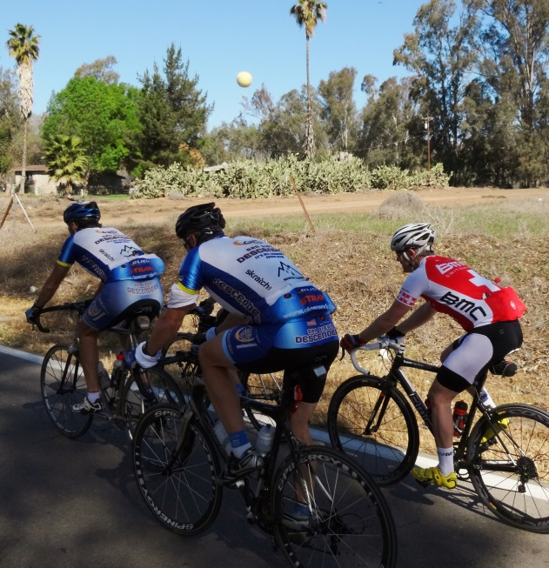  Mike, Claus & Herman near Wild Animal Park | 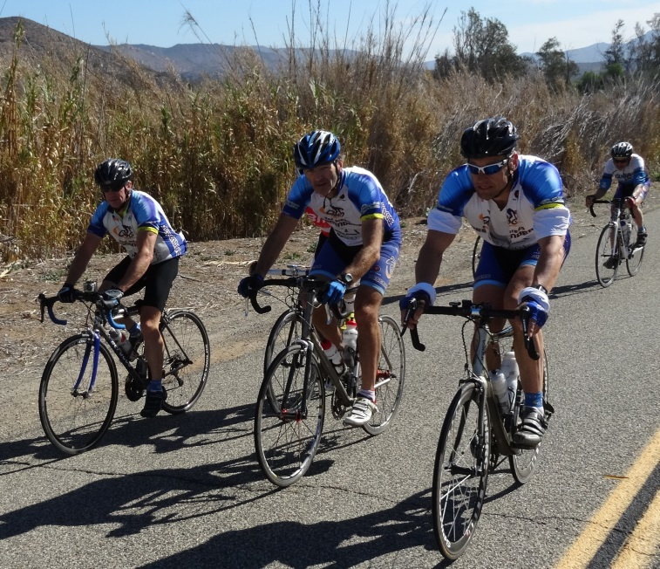  Climbing Summit Road

Santa Ysabel Creek is a short, sandy and patchy section of road but we all made it back to 78 and turned west. We took the side road, Old Pasquel Road, to avoid the major traffic. This was also the BWR route in reverse. We climbed up Summit to Mary Lane and then descended down to Kit Carson Park where Mike ended his ride. Tony turned right onto Bear Valley to head home while John M, Herman, Claus, Len and I road back over the pedestrian bridge. Len and Herman went left down Pomerado while we headed back through 4S and up the climb behind Black Mountain.

Claus was well behind in his normal century rides for the weekend and he had a tight schedule due to a family swim meet. At the top of BMR I waited for John and suggested to Claus to keep riding all the way to Carmel Valley Road before returning on the bike path. He did so, got to about 93 miles for the day and was riding just a quarter mile in front of Guido who was returning from his fast, solo ride. Bob P spotted both guys riding on the bike path as he was driving home. Descenders are riding everywhere! John and I headed down into PQ and I got home with about 53 miles of riding and another bike cleaning effort ahead.

It was a super fun weekend of road and dirt riding, BWR at its best. Thanks to Mike Hodges for hosting and coercing us to ride in the dirt. As Oleg loves to quote, “You should have come.”

